Department of Design Engineering and Mathematics

Middlesex University



**Development of Control and Interface Systems for a Flight Simulation Experience**

**Omar Maaouane Veiga**

Supervisor: Michael Margolis

PDE3823 Major Project and Professional Practice

*BEng Robotics and Mechatronics Engineering*

2024 - 2025

Acknowledgements

I would like to sincerely thank my supervisor, Michael Margolis, for his invaluable support throughout this project. His previous work on the MDX rollercoaster motion platform provided a substantial codebase for controlling the platform, which served as the foundation for my own project. Were it not for his contributions, my project would not have been nearly as complete as it is. I am deeply grateful for his continuous support in all aspects of the project, including planning and determining the best approach.

Abstract

**WRITE LAST (Week 11)**

This report presents the design and development of a control and interface system for a flight simulation ride experience. The project is conducted in collaboration with other final-year students and the Royal Aeronautical Society as part of the Falcon 2 program [1], with Coventry University contributing by designing virtual flight experiences in X-Plane 11, the chosen flight simulator. The aim is to create an accessible ride for outreach events such as school visits and expositions.

While other students focus on designing the accessibility features of the simulator, this project focuses on developing software tools to enable a custom-built Stewart-type motion platform to deliver an immersive experience comparable to existing flight simulators. A key aspect of this work is the novel use of fluidic muscle actuators—operating without position feedback—for motion platform control via X-Plane, introducing unique technical challenges.

The system builds upon pre-existing control software from the MDX rollercoaster platform, adapted for a new wheelchair-accessible design. Extensive experimentation was conducted to evaluate the performance of the new actuators. The final deliverable is a set of accessible tools that connect X-Plane to the motion platform, expanding inclusivity in flight simulation experiences.

Table of contents

1. Introduction 5

1.1. Background and Motivation 5

1.2. Aims and Objectives 7

1.3. Scope and Contributions 9

2. Technical Background And Literature Review 9

2.1. Industry solutions and fundamental concepts 9

2.2. Literature review and critical summary of how previous solutions apply to project 18

3. Another Chapter 18

3.1. Something 18

3.1.1. Subsubsection 18

3.1.2. And another 18

3.2. Something else 18

4. Conclusion 19

References 20

Appendix 23

**List of Figures**

Figure 1.1-Image of a typical 6DOF motion platform used for sim racing 5

Figure 1.2-Render of motion platform to be made in this project 6

Figure 2.1-Side by side comparison of the sanders teacher to the SIMONA research simulator 10

Figure 2.2-PS-6TL-1500 Motion platform by motion systems 10

Figure 2.3-DOF Reality illustration of different platforms they offer, ranging from 2DOF, 3DOF and 6DOF 11

Figure 2.4-Example of a Stewart platform 11

Figure 2.5-Example of linear actuator with feedback position control 12

Figure 2.6-Picture of MDX rollercoaster used in outreach event like New Scientist Live 12

Figure 2.7-Ilustration of load vs stroke graph at different pressures for a Festo fluidic muscle from source [7] 13

Figure 2.8-Past examples from papers of Stewart motion platforms using fluidic muscles as actuators 14

**List of tables**

Table 1‑1 List of objectives this project aims to achieve 8

Table 3‑1 Wearable devices used in sports medicine 18

# Introduction

## Background and Motivation

A motion platform in the context of virtual simulators, such as flight and racing simulators, is a mechanically actuated system designed to replicate real-world movements by tilting, rotating, or translating in response to simulated forces. Figure 1.1 is an example of a commercial flight motion platform sold by ca company called “DOF Reality” which offers several types suited for different experiences such as sim racing, flight sim, heli sim or universal [2].

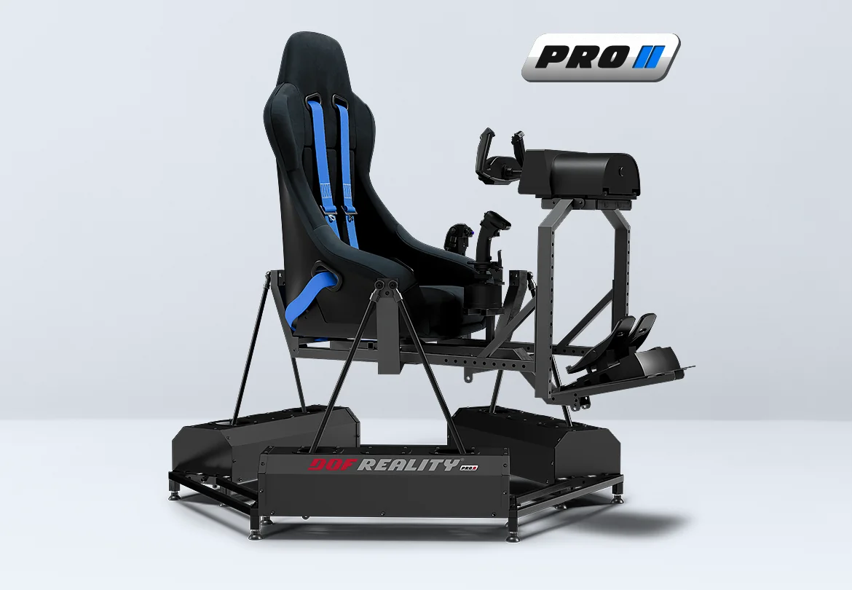

Figure .-Image of a typical 6DOF motion platform used for sim racing

Motion platforms come in many forms. Using DOF Reality [2] as an example, platforms can come in 2DOF (Degrees Of Freedom), 3DOF or 6DOF. Most existing motion platforms make use of a 6DOF “stewart platform” configuration which allows the platform to move forwards, backward, up/down as well as roll, pitch and yaw. The motion platform in this project will be a modified version of the MDX rollercoaster ride which allows wheel chair users to ride the platform by mounting their chair onto a cart that is pulled onto the platform. Render of final platform to be implemented is shown in Figure 1.2.

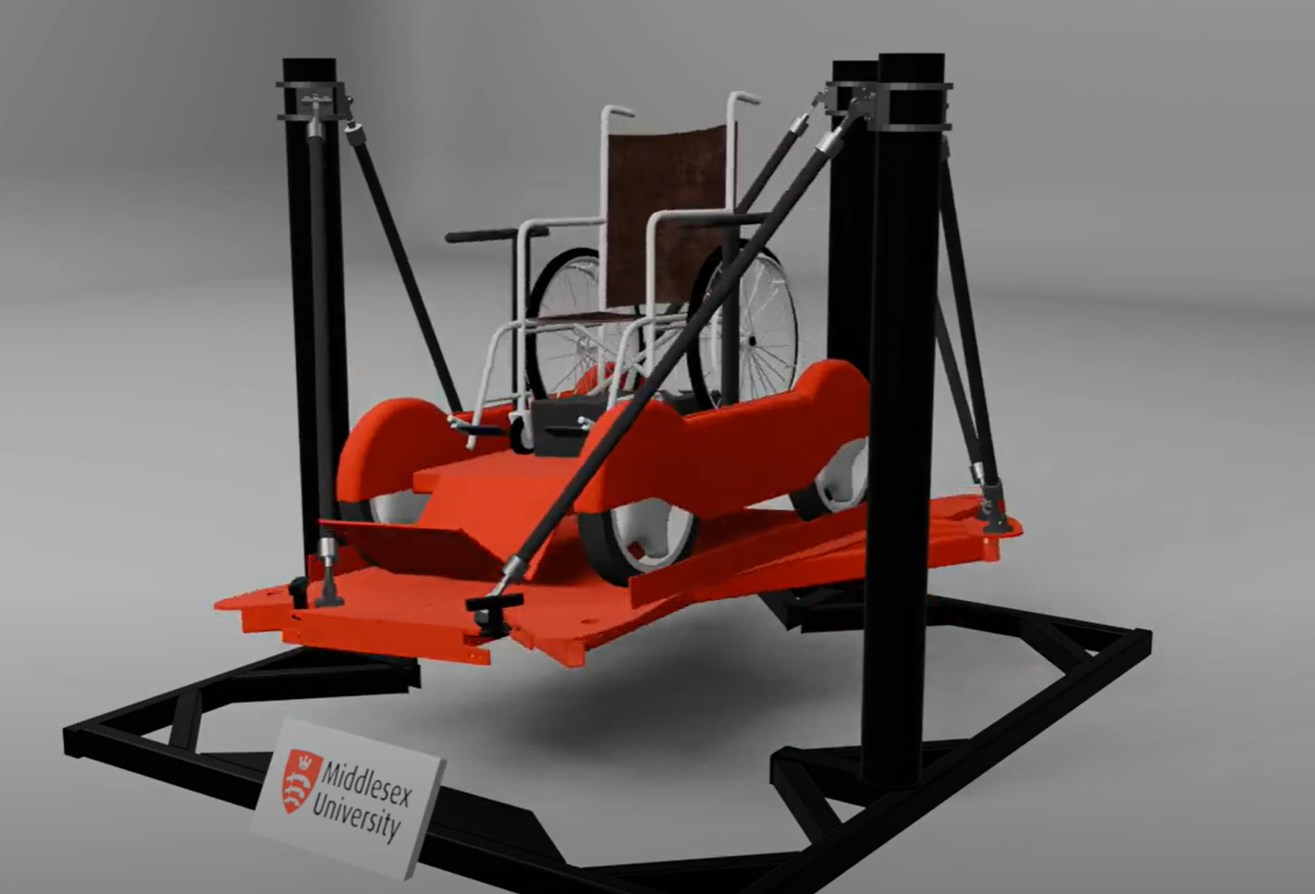

Figure .-Render of motion platform to be made in this project

Since this project focuses on the control software that interfaces between the simulator and the physical platform, the configuration and details of the physical system were already known from the outset. However, due to the platform’s unique design, several gaps in knowledge needed to be addressed. Moreover, the project followed an agile development cycle, meaning there was continuous feedback from the RAes and Coventry University, which constantly shaped the project’s requirements. The agile approach introduced an additional challenge, requiring further adaptability on top of the inherent challenges of the project.

It’s also worth noting that the project’s success criteria does include the project being able to be used by the RAeS. This is due to project’s timespan being too short to allow proper commercial testing. Instead the project will aim to fulfil their requirements without the intention of it being used commercially by the RAes.

Most motion platforms use electric, hydraulic, or pneumatic actuators to create physical motion that corresponds to the virtual environment, enhancing realism and immersion by simulating forces such as acceleration, braking, turbulence, or banking. These platforms are commonly used in professional training, research, and entertainment applications to improve situational awareness and kinesthetic feedback.

Based on the literature review, which is further outlined in a later chapter, this project’s motion platform differs from conventional designs in several ways such as:

* Most motion platforms use rigid actuators controlled hydraulically, pneumatically, or electrically. This project’s platform will be controlled by 6 Festo pneumatic fluidic muscles (similar to traditional McKibben muscles)
* Even when platforms utilize fluidic muscles, they typically include position feedback sensors, allowing for precise position control. Due to project time constraints and limited control over hardware selection, an open-loop control scheme had to be implemented, introducing the challenge of determining pressure-distance characteristics of the muscles.
* There are few examples of motion platforms prioritizing wheelchair accessibility with software designed to accommodate such users.
* The final chair will incorporate newer, longer fluidic muscles that require calibrating in order to set them to a specific length yet without sensing their actual length (open loop).
* The platform configuration differs from conventional Stewart platforms, where actuators operate in compression. This project, however, uses an inverted design, where actuators function in tension.
* There is limited research and development on software that connects the X-Plane flight simulator to motion platforms or peripherals through Python.

The primary challenge this project addresses is the development of a control system for a novel motion platform that differs significantly from standard designs. The use of fluidic muscles without position feedback, combined with a rare platform configuration, presents unique technical challenges in achieving stable and realistic motion. Additionally, the project aims to ensure wheelchair accessibility, an aspect often overlooked in motion platform development.

This work is important because it explores an under-researched approach to motion platform control and expands accessibility in flight simulation experiences. The project’s findings can contribute to future research on alternative actuation methods and inclusive design in simulation-based training and entertainment.

## Aims and Objectives

The goal of this project is to develop software tools that link X-Plane’s aircraft telemetry to a wheelchair-accessible motion platform, enabling a broader range of users to experience and control flight simulations. The project's direction and challenges are largely shaped by the constraints of the pre-existing platform of which my project focuses on. List of key objectives this project aims to achieve is outlined in Table 1‑1

Table ‑ List of objectives this project aims to achieve

|  |  |  |
| --- | --- | --- |
| Requirement number | Requirement Description | Is wish requirement? (*) |
| 1 | Software is able to move mechanical chair in real time with the flight simulation. The ride should not cause motion sickness after at least 2 repeated uses. |  |
| 2 | Software comes with a basic user interface that allows the operator to control how if and how the platform moves according to the input telemetry. |  |
| 3 | Software provides START/PAUSE/STOP functionality to control the ride simulation as required. |  |
| 4 | Software is able to accurately (+-2.5cm) set each muscle’s position to a desired length without muscle length feedback. It will only achieve this by setting their pressure. |  |
| 5 | Software is able to set the platform’s pose accurately enough for each motion to be noticeable to the naked eye. For example the software can move the platform forwards or backwards in a visibly straight line. Target pose accuracy is very lenient in this project. |  |
| 6 | Software takes into account the “safe state” of the wheel chair through input dock sensors. If the chair comes loose itself from the platform, the platform will halt to a stop in a pre-determined “safe state” pose. |  |
| 7 | User interface is friendly and can be easily used by an inexperienced operator with minimal training. | * |
| 8 | User interfaces allows operator to manually control the chair’s pose and see a side by side simulation of it. | * |
| 9 | Software is allows support to connect chair to other flight sims aside from X-Plane. | * |
| 10 | Final ride platform has VR support for further immersion | * |

This project’s key contributions will be adapting previously fragmented work and knowledge from different motion platforms and research on fluidic muscles into a unique design which in the end results in a unique motion platform capable of allowing wheelchair and non-wheelchair users to experience a flight simulation through a motion platform that does uses uncommon actuators in an even more uncommon configuration.

## Scope and Contributions

This project’s key contributions involve integrating previously fragmented work and knowledge from various motion platforms and research on fluidic muscles into a unique design, resulting in a motion platform that allows both wheelchair and non-wheelchair users to experience flight simulation. The platform features unconventional actuators in an even more unique configuration, contributing to the originality and impact of the work.

# Technical Background And Literature Review

## Industry solutions

Motion platforms have existed since 1910 [3]. Originally known as the “Sanders Teacher”, this was developed with the intent of helping trainee airplane pilots. As technology advanced, motion platforms began began appearing more in the context of arcade videogames in the 1980s and now they’re widely available as peripherals to enhance user immersion in flight simulators, racing sims and novelty ride experiences.

Nowadays, motion platforms come in many different configurations. Some can be as big as the SIMONA research simulator [4] from the Delft University of Technology which has 6 DOF and uses large hydraulic actuators in a stewart platform configuration to move the user according to the inner cabin flight simulation. Comparison of earliest flight simulator to one of the latest shown in Figure 2.1

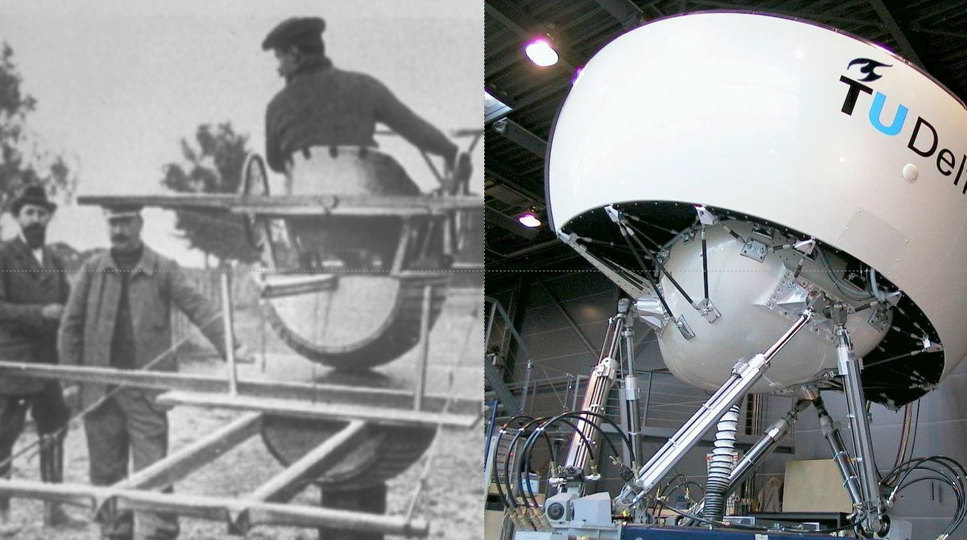

Figure .-Side by side comparison of the sanders teacher to the SIMONA research simulator

There’s also the Motion systems’ PS-6TL-1500 [5] which for a similar size uses rigid electric linear actuators to achieve it’s motion. This platform is mainly intended for professional applications in defence sector, flight and driving simulation and entertainment industry. Shown in Figure 2.2.

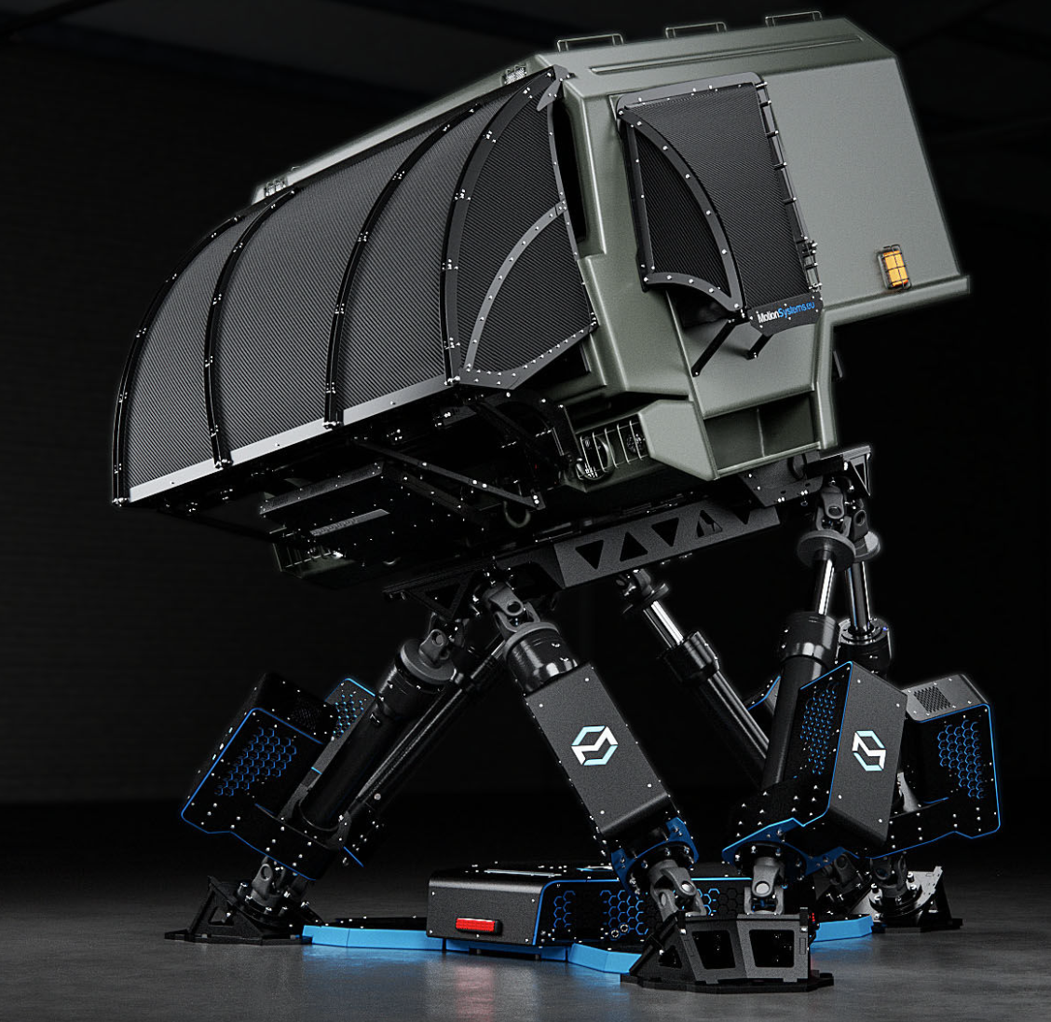

Figure .-PS-6TL-1500 Motion platform by motion systems

In a smaller yet more common scale, there are motion platform which regular consumers can buy that can also offer up to 6DOF. These platforms are intended for home gaming users which seek to be further immersed onto their videogame simulator of choice. There are also lower cost 2DOF and 3DOF platforms which have a lower range of freedom but still aim to provide an immersive gaming experience. 2DOF, 3DOf and 6DOF platforms are illustrated in Figure 2.3.

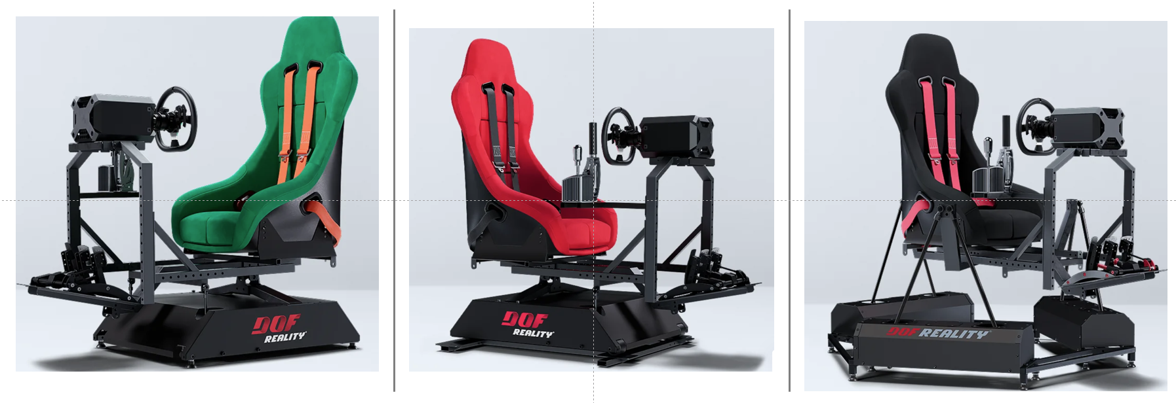

Figure .-DOF Reality illustration of different platforms they offer, ranging from 2DOF, 3DOF and 6DOF

## Fundamental concepts and further research on previous solutions

A common overall trend in industry is to use a stewart platform just like in Figure 2.4. The reason for this is because this confugration conveniently allows for the user standing on the platform to move and rotate in all possible directions through a compact platform with a fairly large working envelope.

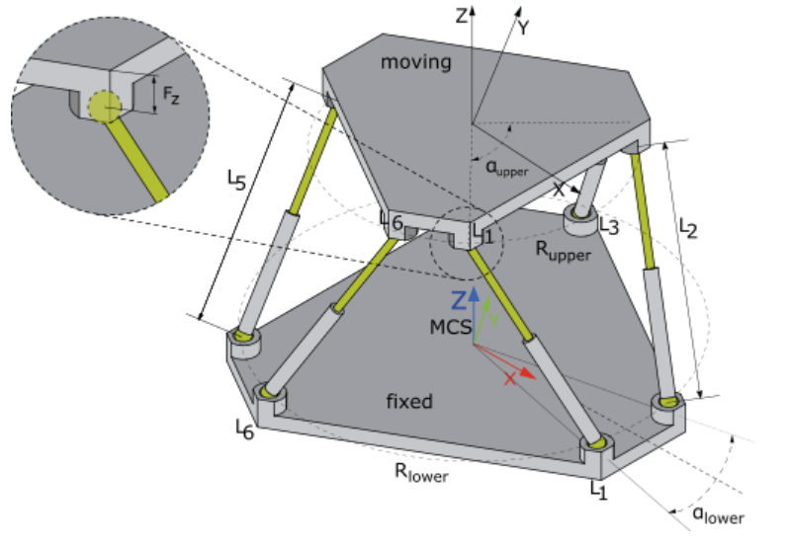

Figure .-Example of a Stewart platform

Another common trend across industry is to use electric, hydraulic or pneumatic actuators with position feedback control which in turn allow each of the six platform actuators to be set at a specific length and therefore achieve a desired pose through inverse kinematics calculations. Example of an actuator with position feedback control is shown in Figure 2.5

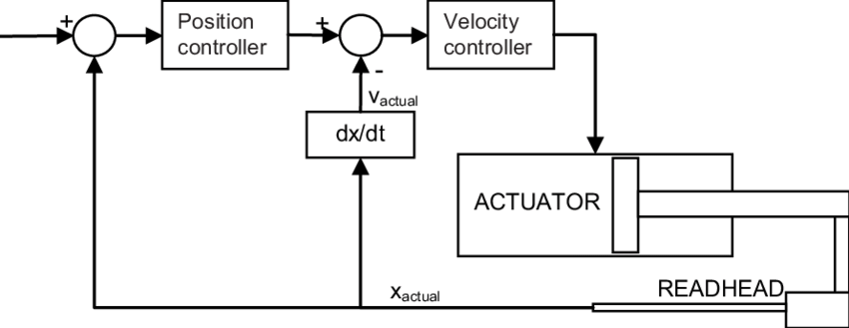

Figure .-Example of linear actuator with feedback position control

Industry does not implement inverted Stewart platforms like the MDX rollercoaster example [6]. This is likely due to the regular configuration offering ground clearance by default and thereby a better movement envelope. MDX rollercoaster shown in Figure 2.6

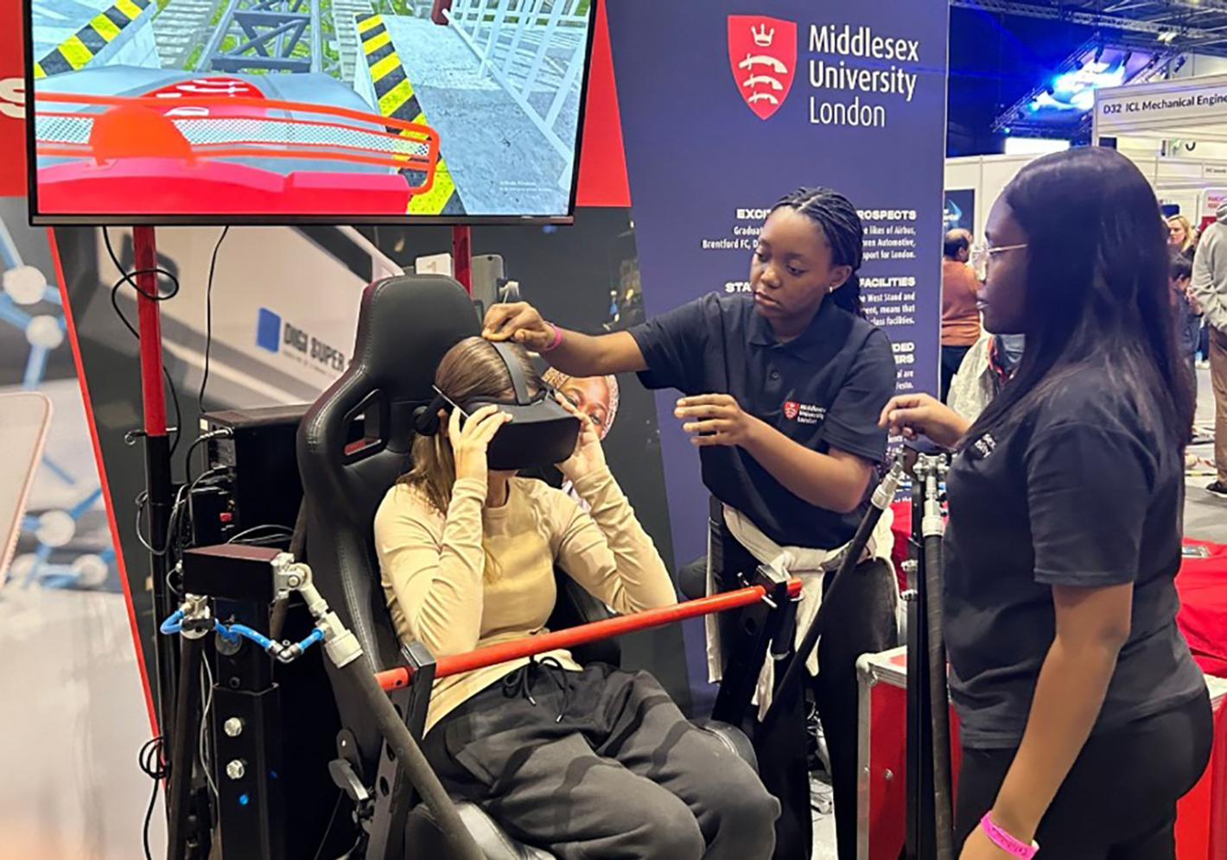

Figure .-Picture of MDX rollercoaster used in outreach event like New Scientist Live

The actuators used for the platform are Festo fluidic muscles. Festo fluidic muscles are pneumatic linear actuators that function similarly to biological muscles. They are made of a flexible tube reinforced with a fiber mesh. When pressurized with air, the tube contracts along its length while expanding radially, generating tensile force (pulling motion). Source [7] evaluates the dynamic model of fluidic muscles in great detail.

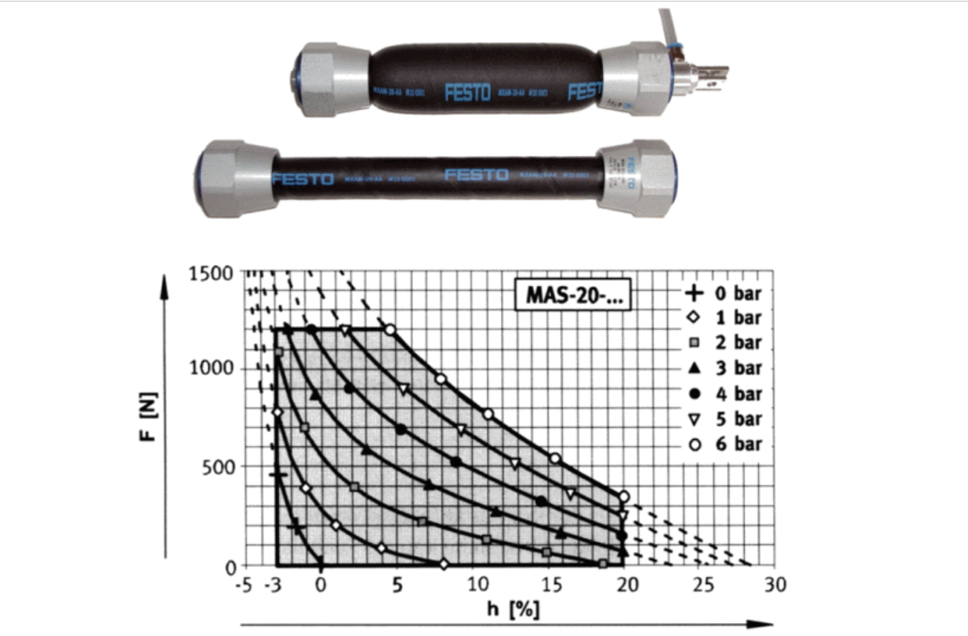

Figure .-Ilustration of load vs stroke graph at different pressures for a Festo fluidic muscle from source [7]

More closely related to this project, research has been conducted on connecting the X-Plane simulator to a motion platform [8] and on using Festo fluidic muscles to control a Stewart platform [9] and [10], though not within the same project. Moreover, the paper on the Stewart platform using Festo muscles describes a setup where the muscles are connected to an upright pre-compressed spring and operate with closed-loop position control—unlike this project's motion platform, which lacks such control. Examples of motion platforms using fluidic muscles is shown in Figure 2.8

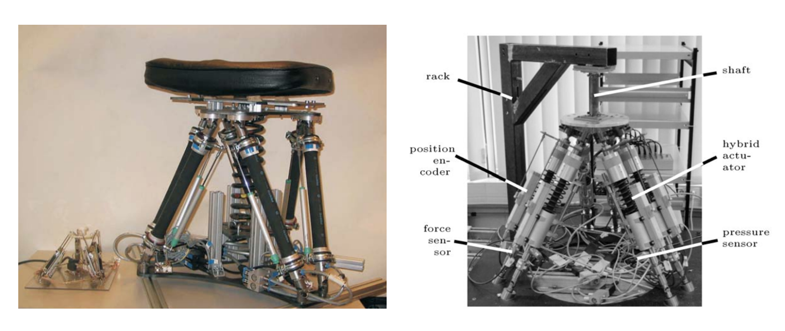

Figure .-Past examples from papers of Stewart motion platforms using fluidic muscles as actuators

Two fundamental concepts required for the platform to work are inverse kinematics [11] and washout filters [12]. Inverse kinematics are a set of mathematical formulas which allow the platform’s controller to take in an input 6D pose (3D translation and 3D rotation) and output the required actuator lengths based on the platforms physical characteristics. In turn this allows the physical platform to achieve the desired pose which is easier to set than manually controlling every muscle’s stroke individually.

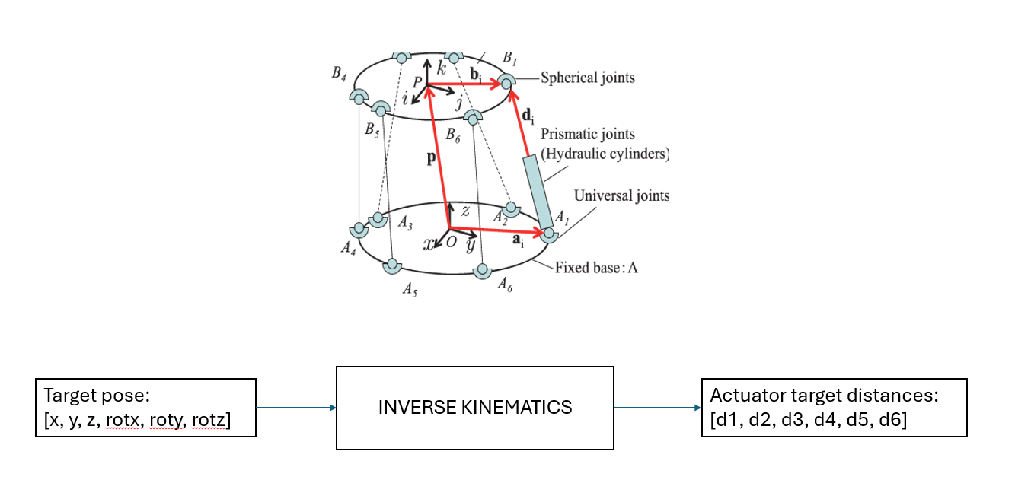

Figure .-Inverse kinematics of a Stewart Platform illustration

Another key concept in motion platforms which will become more relevant later on the project’s development are washout filters. Washout filters are implemented between the target pose and inverse kinematics stage of the motion simulation as shown in Figure 2.10.

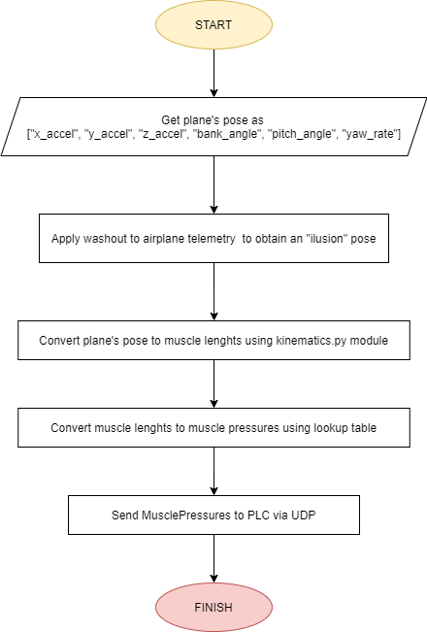

Figure .-Plane Pose to muscle distances accounting for washout. This graph is from around project week 5.

Washout filters in motion platforms are motion cueing algorithms used to create realistic motion sensations while keeping the platform within its physical limits. They filter and scale the movement data from the simulator to prevent excessive displacement while still providing a convincing sense of acceleration and orientation changes. The paper [12] further explains the concept of washout in further mathematical detail. The video in resource [13] qualitatively explains how flight simulators trick the human brain into believing they are flying an aircraft while using the SIMONA research simulator [4] as an example.

Figure 2.11 demonstrates how a washout filter gradually moves the platform back to its resting roll position once the plane’s angular roll acceleration ceases. This ensures the platform remains within its physical constraints while maintaining the illusion of rolling in an actual plane. It is worth noting that using widescreen monitors and covering as much of the user’s field of view significantly enhances the illusion of movement, as visual and vestibular inputs are the key factors that make the brain perceive motion.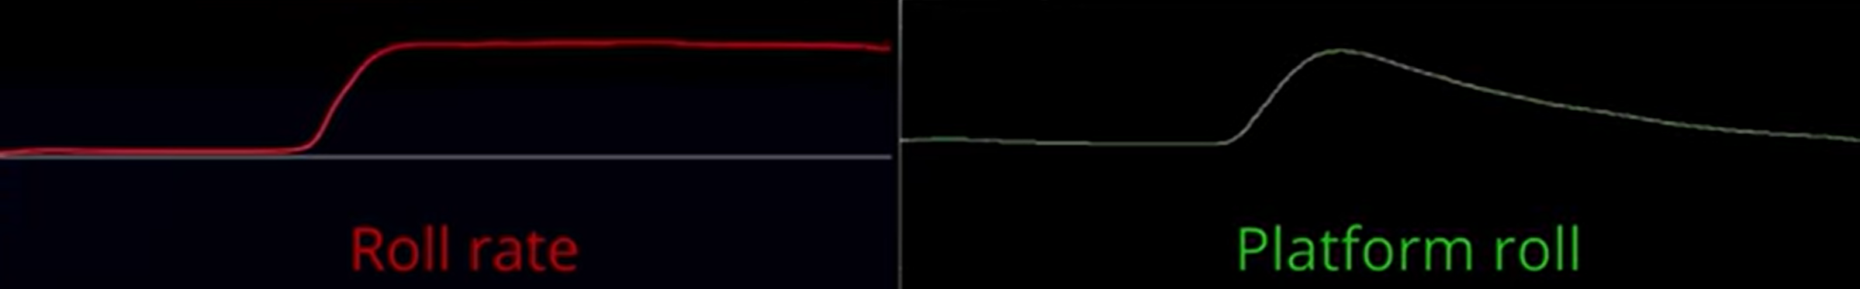

Figure .-Washout filter illustration for roll and pitch

Figure 2.12 illustrates another way washout filters enhance the illusion of movement. By slightly tilting the user and covering their field of view, a reaction force is created against the chair, which, over time, becomes indistinguishable from acceleration in an actual plane.

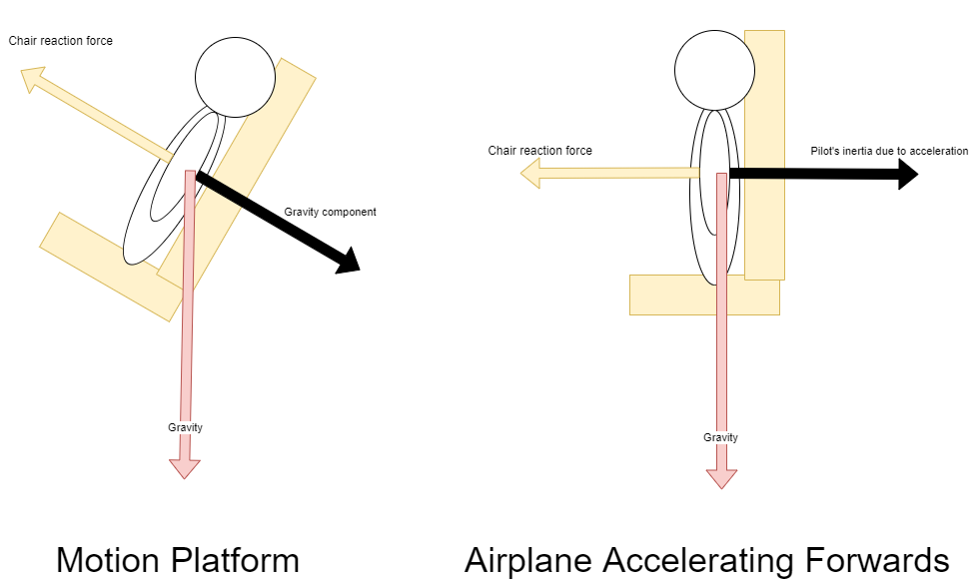

Figure .- Illustration of illusion made by motion platforms to create the sense of acceleration

Figure 2.13 illustrates in better detail how the platform will create an illusion of acceleration during take-off by directly surging forwards for immediate acceleration and slowly tilting over time to create an illusion of constant acceleration.

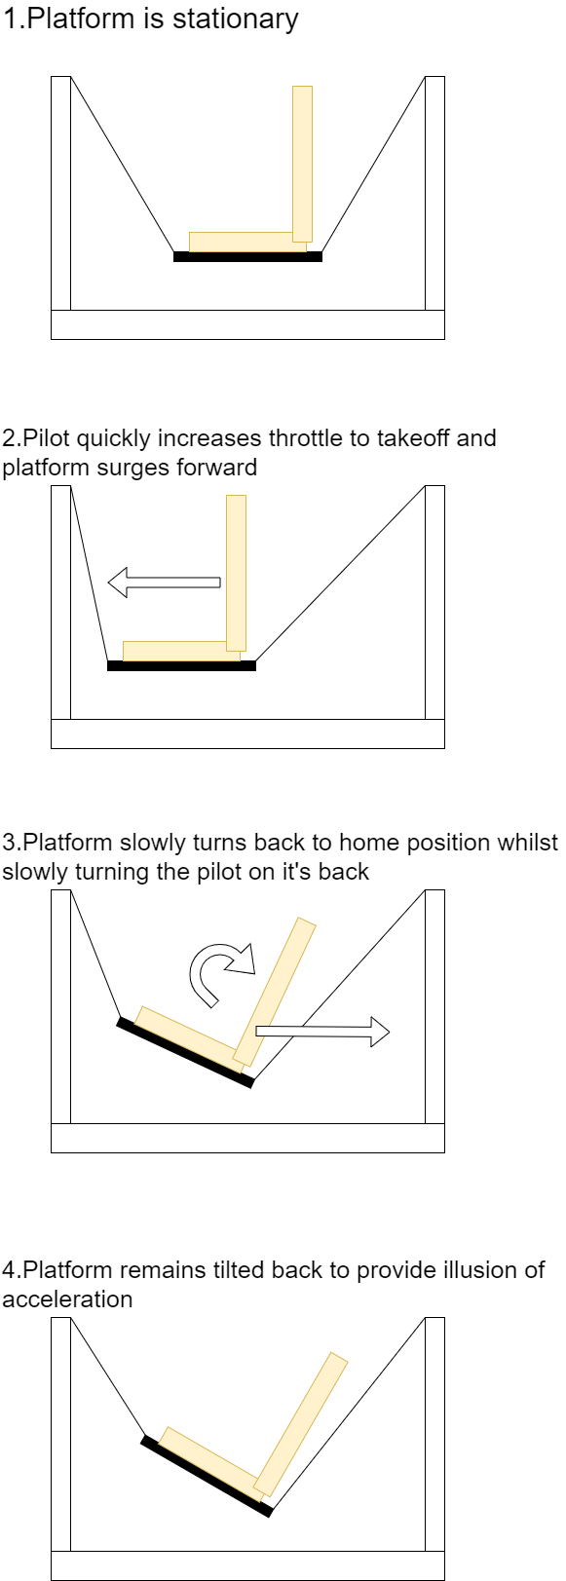

Figure .-Ilustration of washout for low frequency transient acceleration

Finally, a key detail worth noting is that the pressure-to-distance characteristics of the fluidic muscle are nonlinear due to the high 'dry friction' between the muscle fibers. One notable approach, presented in paper [14], used a multi-layer perceptron (MLP) network trained on muscle pressure and angle data to develop a model with 84.66% accuracy, capable of controlling a planar 2DOF fluidic muscle robotic arm. This paper highlights the importance of different approaches in modeling nonlinear systems. Figure 2.14 shows an illustration from the paper of planar 3DOF robotic arm

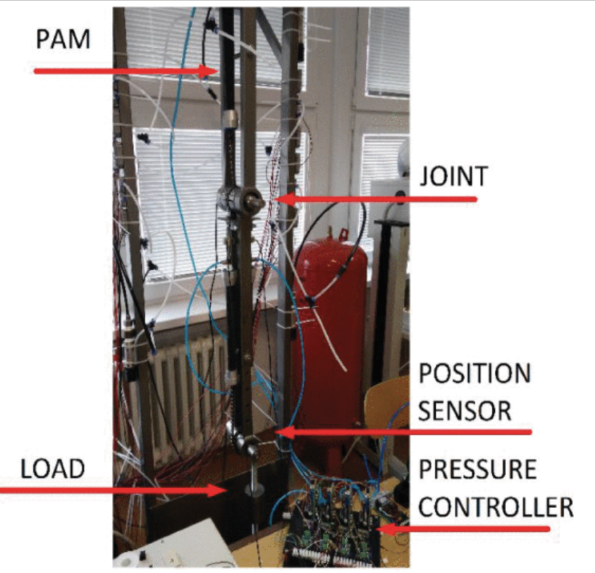

Figure .-Illustration from paper [14] of a planar robotic arm controller by two fluidic muscles

A simpler yet still functional approach which was used for the MDX rollercoaster platform will be to map the muscle’s pressures and distances to a table for a known load as illustrated in Figure 2.15.

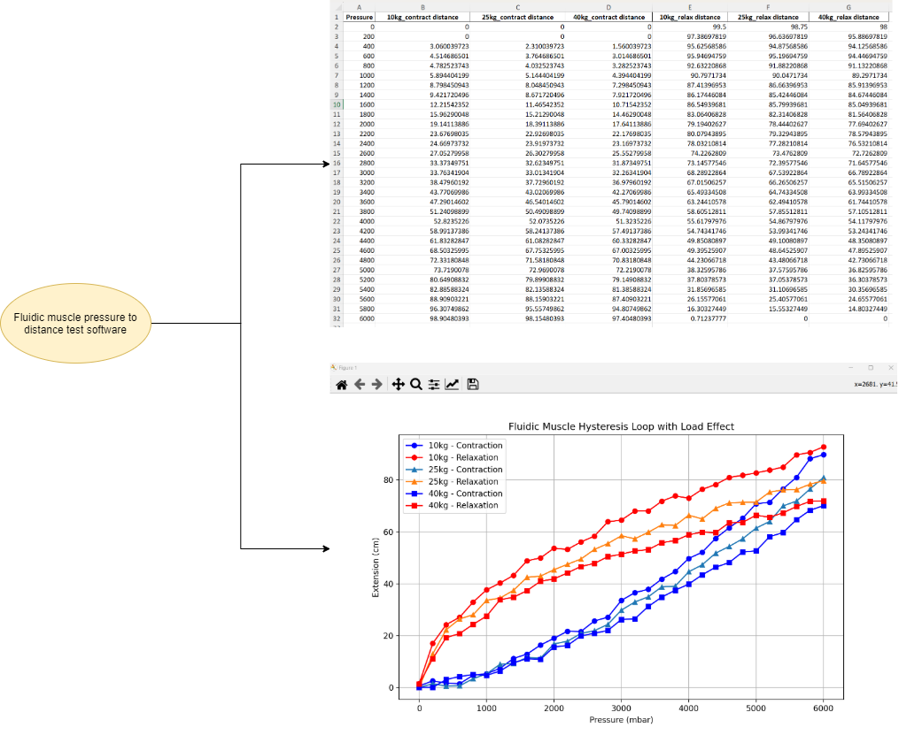

Figure .-Illustration of results the program aims to provide with in the Week 8 experiments

Using this lookup table approach will still ensure that the correct pressure is applied to each muscle for a given load, allowing the appropriate distance to be achieved and, consequently, the target pose.

Table 2‑1 below summarizes and compares relevant industry solutions and research papers based on key criteria, highlighting their strengths and limitations in relation to this project.

Table ‑-Comparison of existing solutions

|  |  |  |  |  |  |
| --- | --- | --- | --- | --- | --- |
| **Solution/Research** | **DOF** | **Actuation Type** | **Control Method** | **Position Feedback** | **Application Relevance** |
| Sanders Teacher [3] | 2DOF | Mechanical | Manual Control | No | Early flight training |
| SIMONA Simulator [4] | 6DOF | Hydraulic | Closed-loop | Yes | High-fidelity flight simulation |
| PS-6TL-1500 [5] | 6DOF | Electric Linear Actuators | Closed-loop | Yes | Professional defense and simulation |
| MDX Rollercoaster [6] | 6DOF | Fluidic Muscles | Open-loop | No | Amusement ride, outreach events |
| X-Plane Motion Platform from video [8] | 6DOF | Various | Closed-loop | Yes | Motion platform software integration |
| Paper on Fluidic Muscle Stewart Platform [9] | 6DOF | Fluidic Muscles | Closed-loop | Yes | Research on pneumatic actuators |
| Paper on MLP-based Fluidic Muscle Control [14] | 2DOF | Fluidic Muscles | Machine Learning (MLP) | Yes | Nonlinear actuator modeling |
| **This Project** | **6DOF** | **Fluidic Muscles** | **Open-loop (Lookup Table)** | **No** | **Accessible motion platform for simulation** |

## Literature review and critical summary of how previous solutions apply to project

Existing research and industry solutions have primarily focused on closed-loop control with rigid actuators, whereas this project implements an open-loop control scheme for an inverted Stewart platform using fluidic muscles. Unlike traditional Stewart platforms, this platform prioritizes accessibility by supporting both wheelchair and non-wheelchair users. Additionally, while past research on fluidic muscles has leveraged machine learning for modelling, this project adopts a lookup table approach due to practical constraints.

By integrating fragmented knowledge from motion platforms, flight simulation, and fluidic muscle actuation, this project contributes a novel approach to motion platform design, enhancing accessibility while addressing unique technical challenges in open-loop control and nonlinear actuator modelling.

# Another Chapter

Some initial text.

## Something

Text

### Subsubsection

Text

### And another

Text

Table ‑ Wearable devices used in sports medicine

|  |  |
| --- | --- |
| **Wearable Device** | **Functional Mechanism** |
| **Movement sensors** | |
| Pedometer | “Step” recorded each instance the vertical acceleration of a spring-loaded lever arm exceeds the force sensitivity threshold |
| Accelerometer/gyroscope | Acceleration causes deflection of a seismic mass between 2 electrodes, causing a change in capacitance |
| GPS | Signal transmissions from multiple orbiting satellites are acquired by a ground-based receiver; the relative delay is used to calculate the speed and position of the receiver |
| **Physiologic sensors** | |
| Heart rate monitor | 1. Electrical activity from the heart recorded by electrodes in a chest strap |
| 2. Peripheral pulse detected by optical-sensing technology in a wristband |
| Temperature monitor | 1. Ingestible capsule transmits readings to external data log system |
| 2. Armband measures skin convective heat flux in temperature |
| Integrated sensors | Multimodal platforms that incorporate components of movement and physiologic sensors |

Table 1 shows….

## Something else

Text

# Conclusion

# References

|  |  |
| --- | --- |
| [1] | “Falcon 2 programme homepage,” [Online]. Available: https://www.aerosociety.com/careers-education/schools-outreach/the-falcon-2-programme/ . |
| [2] | “DOF Reality Home Page,” [Online]. Available: https://dofreality.com/. |
| [3] | “Brief history of the motion simulator webpage,” [Online]. Available: https://www.wearetricycle.co.uk/pages/the-history-of-the-motion-simulator. |
| [4] | “SIMONA research simulator,” [Online]. Available: https://cs.lr.tudelft.nl/simona/facility/. |
| [5] | “Motion systems PS-6TL-1500 homepage,” [Online]. Available: https://motionsystems.eu/product/motion-platforms/ps-6tl-1500/. |
| [6] | “MDX rollercoaster news page,” [Online]. Available: https://www.mdx.ac.uk/news/2024/12/new-scientist/. |
| [7] | “Paper on evaluation of the dynamic model of fluidic muscles,” [Online]. Available: https://ieeexplore.ieee.org/abstract/document/1639161. |
| [8] | “X-Plane 11 6DOF platform project (does not implement washout filters),” [Online]. Available: https://www.youtube.com/watch?v=KMqd8JA2sos. |
| [9] | “Paper on making stewart platform with fluidic muscles,” [Online]. Available: https://link.springer.com/article/10.1007/s11012-010-9407-8. |
| [10] | R. N. a. H. B. Hubert Gattringer, “Paper on the modelling and control of a pneumatically driven stewart platform,” [Online]. Available: https://www.ferrobotics.com/app/uploads/2020/11/Publikation_movic2008_Gattringer_Naderer.pdf. |
| [11] | “Paper about the inverse kinematics of a Stewart platform,” [Online]. |
| [12] | H. G. a. H. B. Klemens Springer, “Paper on washout filter concepts for motion simulators on the base of a stewart platform,” [Online]. Available: https://onlinelibrary.wiley.com/doi/pdf/10.1002/pamm.201110448. |
| [13] | “Video qualitatively explaining basic concepts of washout in flight simulation,” [Online]. Available: https://www.youtube.com/watch?v=pfTdJD2OakA&t=31s. |
| [14] | “Dynamics Identification of Fluidic Muscle-actuated Planar Manipulator Using Two Nonlinear Models,” [Online]. Available: https://ieeexplore.ieee.org/stamp/stamp.jsp?tp=&arnumber=9108711&isnumber=9108708. |
| [15] | “Motion platform Github page,” [Online]. Available: https://github.com/michaelmargolis/MdxMotionPlatformV3 . |
| [16] | “XPPython homepage,” [Online]. Available: https://xppython3.readthedocs.io/en/3.1.5/index.html . |
| [17] | “Stewart_Py repository,” [Online]. Available: https://github.com/Yeok-c/Stewart_Py . |
| [18] | “Qt Designer manual page,” [Online]. Available: https://doc.qt.io/qt-5/qtdesigner-manual.html . |
| [19] | “Week 3 progress video,” [Online]. Available: https://www.youtube.com/watch?v=QdajpwCDKjQ . |
| [20] | “Week 4 progress video,” [Online]. Available: https://www.youtube.com/watch?v=oGQuVQyeZ1E . |
| [21] | “XPPython plugin overview page,” [Online]. Available: https://xppython3.readthedocs.io/en/latest/development/index.html . |
| [22] | “Week 5 progress video,” [Online]. Available: https://youtu.be/e6HdSpvxMwY . |
| [23] | “Week 6 progress video (X-Plane and IK module implementation),” [Online]. Available: https://youtube.com/shorts/xT4uXKdkpEs . |
| [24] | M. Rouillet, “Sketchfab wheelchair model,” [Online]. Available: https://sketchfab.com/3d-models/wheelchair-54911b7d81a44991804c87c6fc58c4df . |
| [25] | “Official Blender character rig page,” [Online]. Available: https://studio.blender.org/characters/ . |
| [26] | “Week 6 progress video,” [Online]. Available: https://youtu.be/Di_SnEIQpI4 . |
| [27] | “Unity display app source code repo,” [Online]. Available: https://drive.google.com/drive/folders/1-X01xMI0iL_UhBGNBjc6xrkrSI3d4_Iv?usp=sharing . |
| [28] | “Final platform prototype render animation in Blender,” [Online]. Available: https://www.youtube.com/watch?v=-rCQpAGn2FM. |

# Appendix